**Zhumagali Kanat IT2-2003**

**Practice 8**

* + 1. Create a package specification and body called JOB_PKG, containing a copy of your ADD_JOB, UPD_JOB, and DEL_JOB procedures as well as your GET_JOB function.

**Note:** Use the code from your previously saved procedures and functions when creating the package. You can copy the code in a procedure or function, and then paste the code into the appropriate section of the package.

* + - 1. Create the package specification including the procedures and function headings as public constructs.
      2. Create the package body with the implementations for each of the subprograms.
         1. The ADD_JOB, UPD_JOB, and DEL_JOB procedures
         2. The GET_JOB function
      3. Invoke your ADD_JOB package procedure by passing the values IT_SYSAN and SYSTEMS ANALYST as parameters.
      4. Query the JOBS table to see the result.

create or replace package job_pkg is

procedure add_job (j_id jobs.job_id%type, j_title in jobs.job_title%type);

procedure upd_job(

j_id jobs.job_id%type,

j_ntitle jobs.job_title%type);

procedure del_job(

j_id jobs.job_id%type

);

function get_job(j_id jobs.job_id%type) return jobs.job_title%type;

end job_pkg;

create or replace package body job_pkg is

procedure add_job(

j_id in jobs.job_id%type,

j_title in jobs.job_title%type) is

begin

insert into jobs(job_id, job_title) values (j_id,j_title);

end add_job;

procedure upd_job(

j_id jobs.job_id%type,

j_ntitle jobs.job_title%type) is

begin

update jobs set job_title = j_ntitle where job_id = j_id;

if(sql%rowcount = 0) then dbms_output.put_line ('No data found for updating...');

else dbms_output.put_line('Nice! ');

end if;

exception when others then dbms_output.put_line('error');

end upd_job;

procedure del_job(

j_id jobs.job_id%type

) is

begin

delete from jobs where job_id = j_id;

if(sql%rowcount = 0) then dbms_output.put_line ('No data found for deleting...');

else dbms_output.put_line('Nice! ');

end if;

exception

when others then dbms_output.put_line('error');

end del_job;

function get_job(j_id jobs.job_id%type) return jobs.job_title%type is j_title jobs.job_title%type;

begin

select job_title into j_title from jobs where job_id = j_id;

return j_title;

end get_job;

end job_pkg;

execute job_pkg.add_job('IT_SYSAN', 'SYSTEMS ANALYST')

select * from jobs

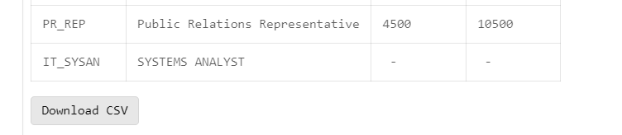

2. Create and invoke a package that contains private and public constructs.

* + - 1. Create a package specification and a package body called EMP_PKG that contains the following procedures and function that you created earlier:
         * ADD_EMPLOYEE procedure as a *public* construct
         * GET_EMPLOYEE procedure as a *public* construct
         * VALID_DEPTID function as a *private* construct

1. Invoke the EMP_PKG.ADD_EMPLOYEE procedure, using department ID 15 for the employee Jane Harris with the email ID JAHARRIS. Because department ID 15 does not exist, you should get an error message as specified in the exception handler of your procedure.
2. Invoke the ADD_EMPLOYEE package procedure by using department ID 80 for employee David Smith with the email ID DASMITH.
3. Query the EMPLOYEES table to verify that the new employee was added.

create or replace package emp_pkg is

procedure add_employee(

first_name employees.first_name%TYPE,

last_name employees.last_name%TYPE,

email employees.email%TYPE := 'mail',

job employees.job_id%TYPE := 'SA_REP',

mgr employees.manager_id%TYPE := 145,

sal employees.salary%TYPE := 100,

comm employees.commission_pct%TYPE := 0,

deptid employees.department_id%TYPE := 30);

procedure get_employee (

e_id in employees.employee_id%type,

j_id out employees.job_id%type,

salary out employees.salary%type);

end emp_pkg;

create or replace package body emp_pkg is

function valid_deptid (department_id departments.department_id%type ) return boolean is

begin

if department_id is null then return false;

else return true;

end if;

end valid_deptid;

procedure add_employee(

first_name employees.first_name%TYPE,

last_name employees.last_name%TYPE,

email employees.email%TYPE := 'mail',

job employees.job_id%TYPE := 'SA_REP',

mgr employees.manager_id%TYPE := 145,

sal employees.salary%TYPE := 100,

comm employees.commission_pct%TYPE := 0,

deptid employees.department_id%TYPE := 30

)

is

begin

IF valid_deptid(deptid) then

insert into employees(employee_id, first_name, last_name, email, hire_date, job_id, salary, commission_pct, manager_id, department_id)

values (EMPLOYEES_SEQ.nextval, first_name, last_name, email, TRUNC(SYSDATE), job, sal, comm, mgr, deptid);

DBMS_OUTPUT.PUT_LINE('TRUE');

else

DBMS_OUTPUT.PUT_LINE('FALSE');

end if;

end add_employee;

procedure get_employee (

e_id in employees.employee_id%type,

j_id out employees.job_id%type,

salary out employees.salary%type

) is

begin

select salary, job_id into salary, j_id from employees where employee_id = e_id;

exception

when no_data_found then dbms_output.put_line('No data found for this id');

when others then dbms_output.put_line('Error');

end get_employee;

end emp_pkg;

execute emp_pkg.add_employee(first_name => 'Jane', last_name => 'Harris', deptid => 15)

execute emp_pkg.add_employee(first_name => 'David ', last_name => 'Smith ', email => 'DASsMITH',deptid => 80)

select * from employees where email = 'DASMITH'

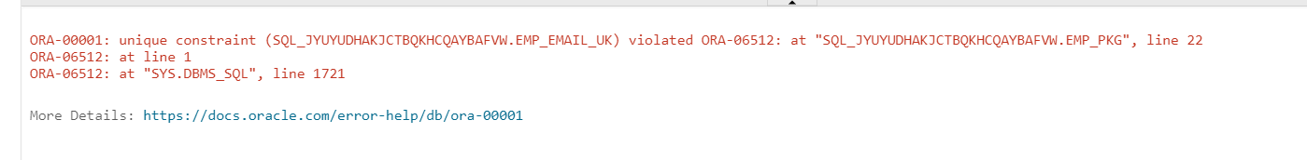 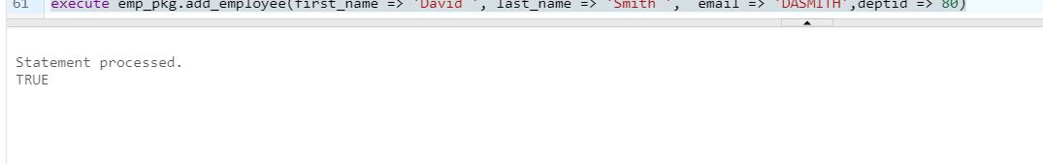

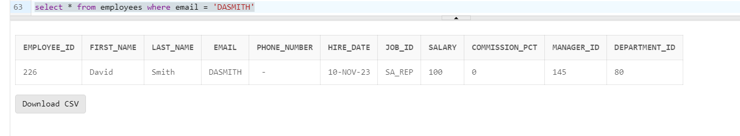

3. Modify the code for the EMP_PKG package, and overload the ADD_EMPLOYEE procedure.

* + - 1. In the package specification, add a new procedure called ADD_EMPLOYEE that accepts the following three parameters:
         1. First name
         2. Last name
         3. Department ID
      2. Click Run Script to create the package. Compile the package.
      3. Implement the new ADD_EMPLOYEE procedure in the package body as follows:
         1. Format the email address in uppercase characters, using the first letter of the first name concatenated with the first seven letters of the last name.
         2. The procedure should call the existing ADD_EMPLOYEE procedure to perform the actual INSERT operation using its parameters and formatted email to supply the values.
         3. Click Run Script to create the package. Compile the package.
      4. Invoke the new ADD_EMPLOYEE procedure using the name Samuel Joplin to be added to department 30.
      5. Confirm that the new employee was added to the EMPLOYEES table.

create or replace package emp_pkg is

procedure add_employee(

first_name employees.first_name%TYPE,

last_name employees.last_name%TYPE,

email employees.email%TYPE := 'mail',

job employees.job_id%TYPE := 'SA_REP',

mgr employees.manager_id%TYPE := 145,

sal employees.salary%TYPE := 100,

comm employees.commission_pct%TYPE := 0,

deptid employees.department_id%TYPE := 30);

procedure add_employee(

first_name employees.first_name%TYPE,

last_name employees.last_name%TYPE,

deptid employees.department_id%TYPE := 30);

procedure get_employee (

e_id in employees.employee_id%type,

j_id out employees.job_id%type,

salary out employees.salary%type);

end emp_pkg;

create or replace package body emp_pkg is

function valid_deptid (department_id departments.department_id%type ) return boolean is

begin

if department_id is null then return false;

else return true;

end if;

end valid_deptid;

procedure add_employee(

first_name employees.first_name%TYPE,

last_name employees.last_name%TYPE,

email employees.email%TYPE := 'mail',

job employees.job_id%TYPE := 'SA_REP',

mgr employees.manager_id%TYPE := 145,

sal employees.salary%TYPE := 100,

comm employees.commission_pct%TYPE := 0,

deptid employees.department_id%TYPE := 30

)

is

begin

IF valid_deptid(deptid) then

insert into employees(employee_id, first_name, last_name, email, hire_date, job_id, salary, commission_pct, manager_id, department_id)

values (EMPLOYEES_SEQ.nextval, first_name, last_name, email, TRUNC(SYSDATE), job, sal, comm, mgr, deptid);

DBMS_OUTPUT.PUT_LINE('TRUE');

else

DBMS_OUTPUT.PUT_LINE('FALSE');

end if;

end add_employee;

procedure add_employee(

first_name employees.first_name%TYPE,

last_name employees.last_name%TYPE,

deptid employees.department_id%TYPE := 30) is em employees.email%type;

begin

em:= UPPER(substr(first_name, 1, 1) || substr(last_name,1,7));

add_employee(first_name, last_name, em);

end add_employee;

procedure get_employee (

e_id in employees.employee_id%type,

j_id out employees.job_id%type,

salary out employees.salary%type

) is

begin

select salary, job_id into salary, j_id from employees where employee_id = e_id;

exception

when no_data_found then dbms_output.put_line('No data found for this id');

when others then dbms_output.put_line('Error');

end get_employee;

end emp_pkg;

execute emp_pkg.add_employee( 'Samuel', 'Joplin', 30)

select * from employees where first_name = 'Samuel'

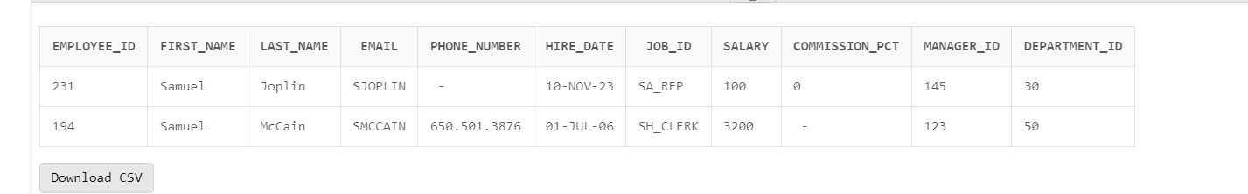

4. In the EMP_PKG package, create two overloaded functions called GET_EMPLOYEE:

* + - 1. In the package specification, add the following functions:
         1. The GET_EMPLOYEE function that accepts the parameter called p_emp_id based on the employees.employee_id%TYPE type. This function should return an EMPLOYEES%ROWTYPE.
         2. The GET_EMPLOYEE function that accepts the parameter called p_family_name of type employees.last_name%TYPE. This function should return an EMPLOYEES%ROWTYPE.
      2. Click the Run Script (F5) icon to re-create the package. Compile the package.
      3. In the package body:
         1. Implement the first GET_EMPLOYEE function to query an employee using the employee’s ID.
         2. Implement the second GET_EMPLOYEE function to use the equality operator on the value supplied in the p_ family_name parameter.
      4. Click Run Script to re-create the package. Compile the package.
      5. Add a utility procedure PRINT_EMPLOYEE to the EMP_PKG package as follows:
         1. The procedure accepts an EMPLOYEES%ROWTYPE as a parameter.
         2. The procedure displays the following for an employee on one line, using the DBMS_OUTPUT package:

- department_id

- employee_id

- first_name

- last_name

- job_id

- salary

f. Click Run Script to re-create the package. Compile the package.

g. Use an anonymous block to invoke the EMP_PKG.GET_EMPLOYEE function with an employee ID of 100 and family name of 'Joplin'. Use the PRINT_EMPLOYEE procedure to display the results for each row returned.

create or replace package emp_pkg is

procedure add_employee(

first_name employees.first_name%TYPE,

last_name employees.last_name%TYPE,

email employees.email%TYPE := 'mail',

job employees.job_id%TYPE := 'SA_REP',

mgr employees.manager_id%TYPE := 145,

sal employees.salary%TYPE := 100,

comm employees.commission_pct%TYPE := 0,

deptid employees.department_id%TYPE := 30);

procedure add_employee(

first_name employees.first_name%TYPE,

last_name employees.last_name%TYPE,

deptid employees.department_id%TYPE := 30);

procedure get_employee (

e_id in employees.employee_id%type,

j_id out employees.job_id%type,

salary out employees.salary%type);

function get_employee(p_emp_id employees.employee_id%type) return employees%rowtype;

function get_employee(p_family_name employees.last_name%type) return employees%rowtype;

procedure print_employee(emp_info employees%ROWTYPE);

end emp_pkg;

create or replace package body emp_pkg is

function get_employee(p_emp_id employees.employee_id%type) return employees%rowtype is emp_info employees%rowtype;

begin

select * into emp_info from employees where employee_id = p_emp_id;

return emp_info;

end get_employee;

function get_employee(p_family_name employees.last_name%type) return employees%rowtype is emp_info employees%rowtype;

begin

select * into emp_info from employees where last_name = p_family_name;

return emp_info;

end get_employee;

function valid_deptid (department_id departments.department_id%type ) return boolean is

begin

if department_id is null then return false;

else return true;

end if;

end valid_deptid;

procedure add_employee(

first_name employees.first_name%TYPE,

last_name employees.last_name%TYPE,

email employees.email%TYPE := 'mail',

job employees.job_id%TYPE := 'SA_REP',

mgr employees.manager_id%TYPE := 145,

sal employees.salary%TYPE := 100,

comm employees.commission_pct%TYPE := 0,

deptid employees.department_id%TYPE := 30

)

is

begin

IF valid_deptid(deptid) then

insert into employees(employee_id, first_name, last_name, email, hire_date, job_id, salary, commission_pct, manager_id, department_id)

values (EMPLOYEES_SEQ.nextval, first_name, last_name, email, TRUNC(SYSDATE), job, sal, comm, mgr, deptid);

DBMS_OUTPUT.PUT_LINE('TRUE');

else

DBMS_OUTPUT.PUT_LINE('FALSE');

end if;

end add_employee;

procedure add_employee(

first_name employees.first_name%TYPE,

last_name employees.last_name%TYPE,

deptid employees.department_id%TYPE := 30) is em employees.email%type;

begin

em:= UPPER(substr(first_name, 1, 1) || substr(last_name,1,7));

add_employee(first_name, last_name, em);

end add_employee;

procedure get_employee (

e_id in employees.employee_id%type,

j_id out employees.job_id%type,

salary out employees.salary%type

) is

begin

select salary, job_id into salary, j_id from employees where employee_id = e_id;

exception

when no_data_found then dbms_output.put_line('No data found for this id');

when others then dbms_output.put_line('Error');

end get_employee;

procedure print_employee(emp_info employees%ROWTYPE) is

begin

dbms_output.put_line('Dep ID: ' || emp_info.department_id ||

' Emp ID: ' || emp_info.employee_id ||

' First Name: ' || emp_info.first_name ||

' Last Name: ' || emp_info.last_name ||

' Job ID: ' || emp_info.job_id ||

' Salary: ' || emp_info.salary);

end print_employee;

end emp_pkg;

declare

e_id employees%ROWTYPE;

e_n employees%ROWTYPE;

begin

e_id := emp_pkg.get_employee(100);

e_n := emp_pkg.get_employee('Joplin');

emp_pkg.print_employee(e_id);

emp_pkg.print_employee(e_n);

end;

